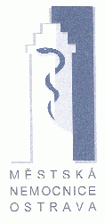
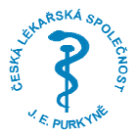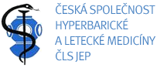

- Announcement

Centre of Hyperbaric Medicine, Municipal Hospital of Ostrava, Czech Republic
Czech Society of Hyperbaric and Aviation Medicine

present

Joint International Conference

2nd OSTRAVA‘S DAYS OF HYPERBARIC MEDICINE
1st CENTRAL EUROPEAN CONFERENCE OF HYPERBARIC AND DIVING MEDICINE

June 17th-18th, 2010, Velke Karlovice, Czech Republic

Conference Chairman:
Michal Hajek, MD

Organizing Committee members:

Jana Kozubova, Bc
Jana Marsalkova
Jarmila Tichavska

Ivana Simkova

Marketa Kis Pisti - Kozakova

Ivo Nemec
Stefan Kis Pisti, MD

Lukas Bil, MD
Michal Hajek, MD

Conference Venue:
Lanterna Hotel, Leskove 659
Velke Karlovice 756 06
Czech Republic

GPS location:
N 49°22´2,19´´, E 018°21´1,14´´

Distance from international airports: Czech Republic- Prague 400km, Brno 190km, Ostrava 70km, Austria- Vienna 250km, Poland- Katowice 200km, Krakow 230km, Slowakia- Zilina 60km

Scientific Topics :
Diving Medicine, Diving Physiology, Decompression Illness,
News in diagnostics and treatment of PFO
Hyperbaric Medicine- Recommended, optional and experimental indications
Hyperbaric Physiology, Experimental HBO,
Oxygen Toxicity
Organization aspects of HBO treatment, Education of HBO staff
Aviation Medicine

Organizing Committee address:
Centre of Hyperbaric Medicine, Municipal Hospital of Ostrava
Nemocnicni 20, Ostrava 1, 728 80, Czech Republic
Phone:+420596192483, e-mail:odhm@mnof.cz

Informations about all important deadlines, applications, instruction for authors, abstract sending, payment, accommodation will be sent by email and published as soon as possible on websites:
www.hbova.cz and www.cshlm.cz

